I got errors when I tried to import the excel file to the database. Then I changed the source excel file into .csv file and sucessfully imported the source data into the database. Below you can find the screenshots :

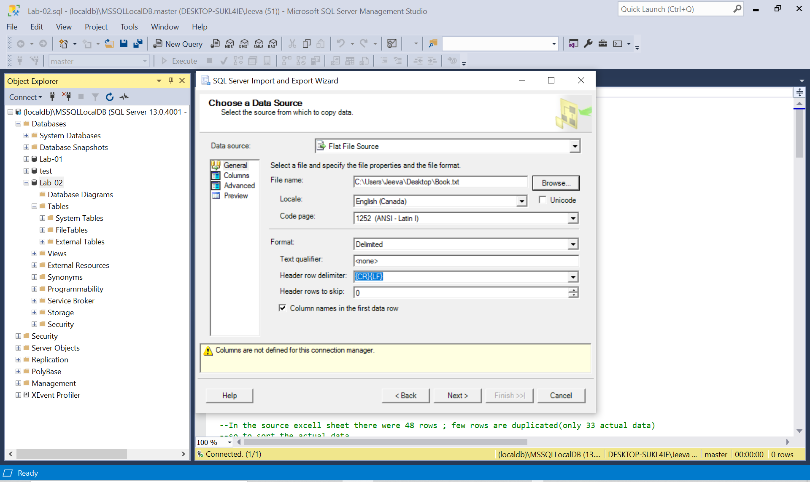

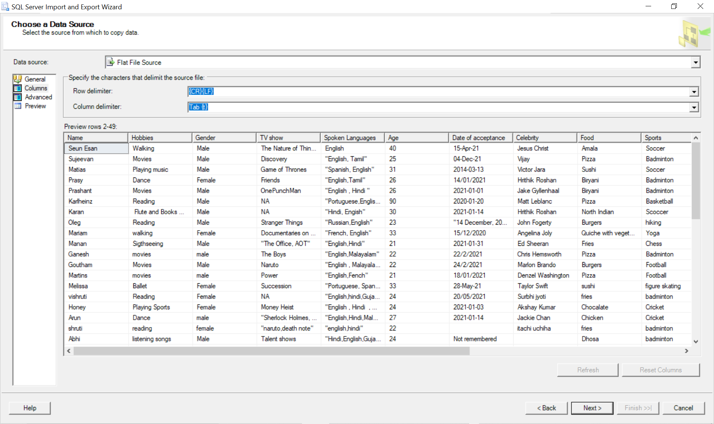

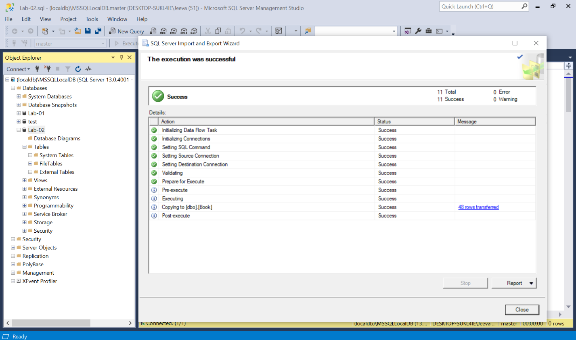

The Quary that I created :

------------------------------------------------------------------------------------------------------------------------------------------

select * from dbo.Book

-- to create a new column for student ID to behave as a primary key

ALTER TABLE Book

ADD studentID int identity(1,1) primary key;

--creating a new table called filteredbook to store the unique book detail

create table filteredbook (

studentID int identity(1,1) not null primary key,

name varchar(100) not null,

Hobbies varchar(300) not null,

Gender varchar(100) not null,

[TV show] varchar(100) not null,

[Spoken Languages] varchar(100) not null,

Age int not null,

[Date of acceptance] varchar (50),

Celebrity varchar(50) not null,

Food varchar (50) not null,

Sports varchar (50) not null,

Color varchar(50) not null,

destination varchar(50) not null,

Transportation varchar (50) not null,

[Dream JOb] varchar(50) not null,

[Most unlike application] varchar (50) not null

)

select * from filteredbook

drop table filteredbook

--In the source excell sheet there were 48 rows ; few rows are duplicated(only 33 actual data)

--so to sort the actual data

--getting the unique values from Book table and storing them inside filteredbook table

insert into filteredbook (Name,Hobbies,Gender, [TV show], [Spoken Languages], Age, [Date of acceptance], Celebrity, Food, Sports, Color, destination, Transportation, [Dream JOb],[Most unlike application])

select distinct Name,Hobbies,Gender, [TV show], [Spoken Languages], Age, [Date of acceptance], Celebrity, Food, Sports, Color, destination, Transportation, [Dream JOb],[Most unlike application] from dbo.Book

--When considering the values in Hobbies, TV show,Spoken languages, Celebrity,food,Sports,.... they have multiple

--values inserted for the same row. So we need to create a seperate table for each column.following tables are

--created for that.

--creating new table to columns which contains more than one values/answers

create table Hobbies (

studentID int foreign key references filteredbook(studentID) not null,

Hobbies varchar(100) not null,

constraint pk_hobbies primary key (studentID, Hobbies)

)

create table [TV show] (

studentID int foreign key references filteredbook(studentID) not null,

[TV show] varchar(100) not null,

constraint pk_TV primary key (studentID, [TV show])

)

create table [Spoken Languages] (

studentID int foreign key references filteredbook(studentID) not null,

[Spoken Languages] varchar(100) not null,

constraint pk_spoken primary key (studentID, [Spoken Languages])

)

create table Celebrity (

studentID int foreign key references filteredbook(studentID) not null,

Celebrity varchar(100) not null,

constraint pk_cele primary key (studentID, Celebrity)

)

create table Food (

studentID int foreign key references filteredbook(studentID) not null,

Food varchar(100) not null,

constraint pk_food primary key (studentID, Food)

)

create table Sports (

studentID int foreign key references filteredbook(studentID) not null,

Sports varchar(100) not null,

constraint pk_sports primary key (studentID, Sports)

)

create table Transportation (

studentID int foreign key references filteredbook(studentID) not null,

Transportation varchar(100) not null,

constraint pk_trans primary key (studentID, Transportation)

)

create table [Dream JOb] (

studentID int foreign key references filteredbook(studentID) not null,

[Dream JOb] varchar(100) not null,

constraint pk_job primary key (studentID, [Dream JOb])

)

create table [Most unlike application] (

studentID int foreign key references filteredbook(studentID) not null,

[Most unlike application] varchar(100) not null,

constraint pk_most primary key (studentID, [Most unlike application])

)

-- inserting values to the tables from the filteredbook table

insert into Hobbies (studentID,Hobbies)

select distinct studentID, Hobbies

from filteredbook

insert into [TV show] (studentID,[TV show])

select distinct studentID, [TV show]

from filteredbook

insert into [Spoken Languages] (studentID,[Spoken Languages])

select distinct studentID, [Spoken Languages]

from filteredbook

insert into Celebrity (studentID,Celebrity)

select distinct studentID, Celebrity

from filteredbook

insert into Food (studentID,Food)

select distinct studentID, Food

from filteredbook

insert into Sports (studentID,Sports)

select distinct studentID, Sports

from filteredbook

insert into Transportation(studentID,Transportation)

select distinct studentID, Transportation

from filteredbook

insert into [Dream JOb](studentID,[Dream JOb])

select distinct studentID, [Dream JOb]

from filteredbook

insert into [Most unlike application](studentID,[Most unlike application])

select distinct studentID, [Most unlike application]

from filteredbook

select * from Hobbies

select * from [TV show]

select * from [Spoken Languages]

select * from Celebrity

select * from Food

select * from Sports

select * from Transportation

select * from [Dream JOb]

select * from [Most unlike application]

SELECT * FROM sys.database_files

-- To findout the student who speaks Tamil

select name,[Spoken Languages] from filteredbook

where [Spoken Languages] like '%Tamil%'

-- To findout people who dont like facebook

select Name,[Most unlike application] from filteredbook where [Most unlike application] = 'Facebook'

-- To findout people who loves Pizza

select Name,Food from filteredbook where Food = 'Pizza'

-- Student who are above 30 years

select Name, Age from filteredbook where Age >30

------------------------------------------------------------------------------------------------------------------------------------------

In the source file there were 49 students name. But only 33 students details are original, other dats are duplicated. Therefore I filtered the datas by using name as a primary key.

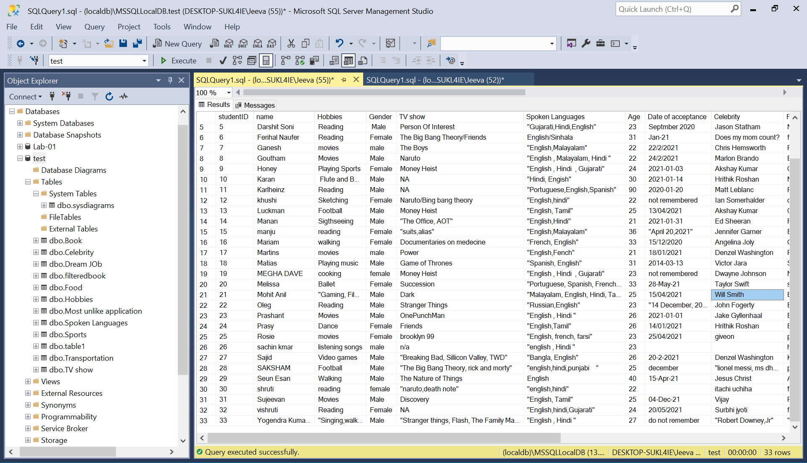

In quary ,

1. Students who speak Tamil

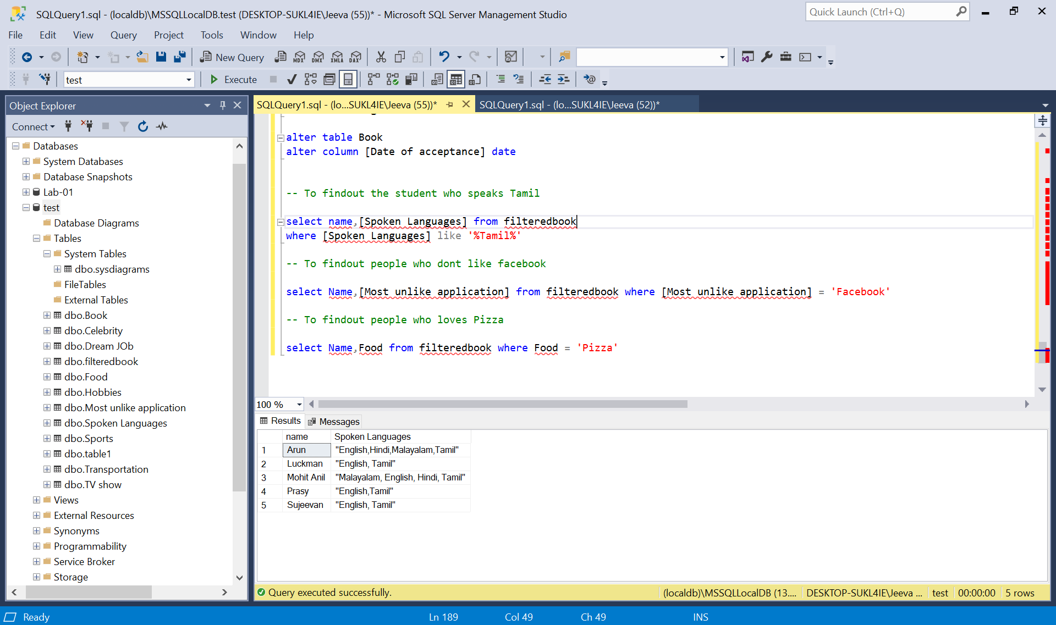

1. Students who do not like Facebook.

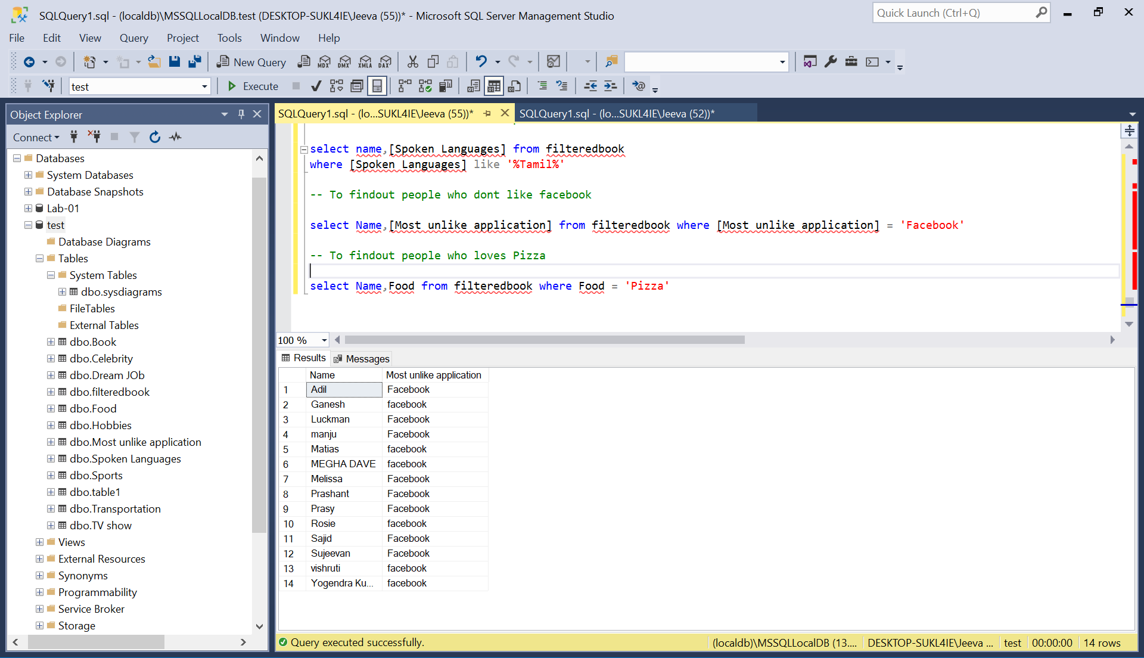

1. Students who like Pizza

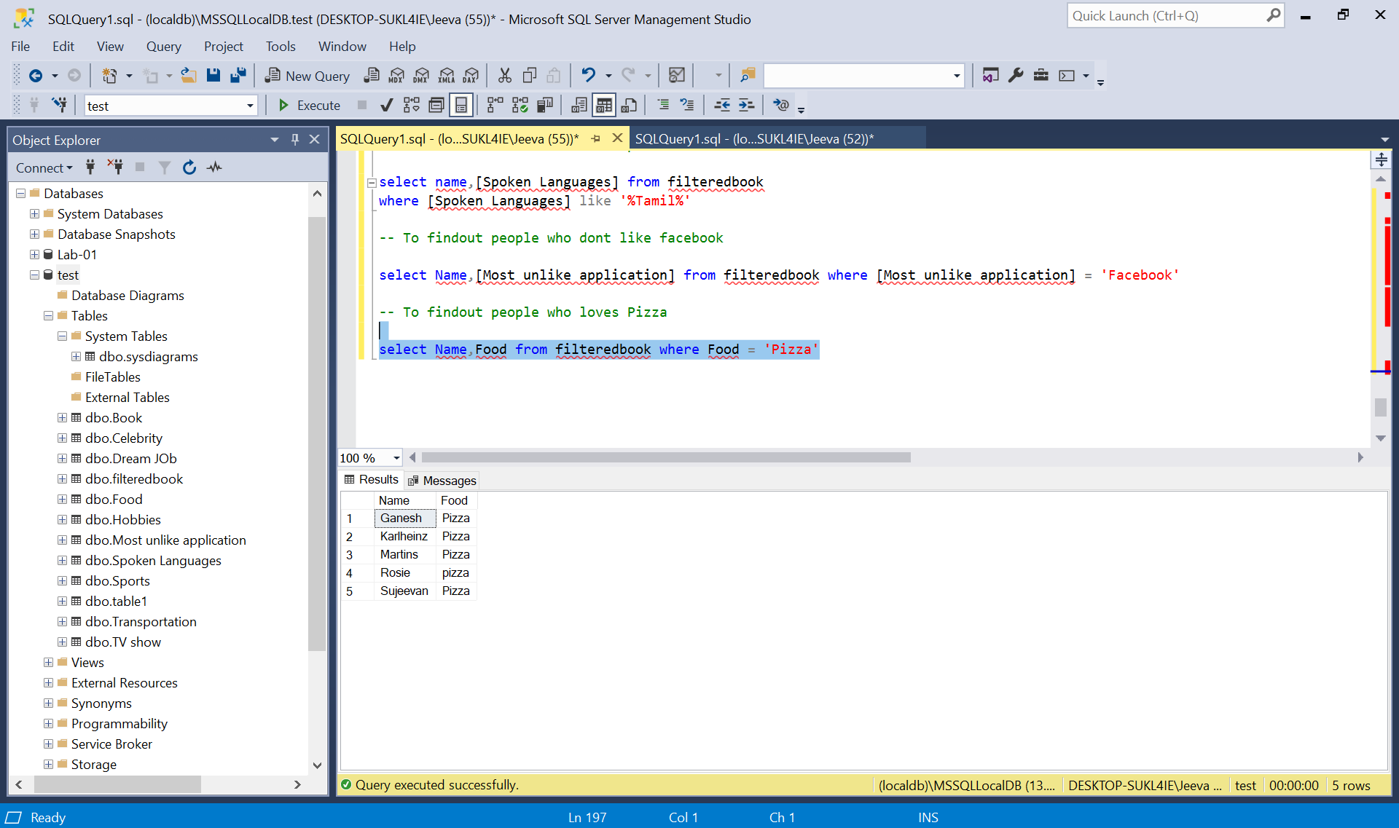

1. Students who are above 30 years

